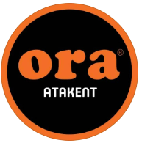

ORA LAHMACUN DIGITAL TRANSFORMATION REPORT

GROUP MEMBERS

211005050 Begüm Özkan

211005015 Kamil Eren

211005006 Busenur Durak

211005048 Barış Mert Tarlacı

201005063 Serhat Tataş

**Contens**

Introduction …………………………………………………………………………………………………………2

Digital Transformation in Türkiye………………………………………………………………………….3-4

Ora Lahmacun………………………………………………………………………………………………….4-5

1.Business Overview……………………………………………………………………………………………….5

1.1 Business Canvas Model……………………………………………………………………………….....5-6

1.2 Swot Analysis……………………………………………………………………………………………………………….6

1.3 Revenue Stream………………………………………………………………………………………………..6

1.4 As-IS Process Flow…………………………………………………………………………………………….7

2. Current State Technology Inventory…………………………………………………………………….7-8

3. Need Assessment…………………………………………………………………………………………….8-9

4. Prioritization Matrix……………………………………………………………………………………………9

5. A Few Examples Worth Investigating…………………………………………………………………….10

6. People, Process Organizational Change……………………………………………………………10-11

7. Technology Options …………………………………………………………………………………………..11

8. Technology Recommendation……………………………………………………………………….11-12

9.Social Media Management………………………………………………………………………………12-13

10. Implementation Roadmap………………………………………………………………………………..13

11. Technology Budget…………………………………………………………………………………………..14

12. Impact to Business…………………………………………………………………………………………..15

13. Business Metrics……………………………………………………………………………………………..15

14. References……………………………………………………………………………………………………..16

INTRODUCTION

In today's world, digital transformation is vital for businesses and organizations to survive and gain competitive advantage. The dynamics of the business world are changing rapidly, customer expectations are increasing, and technological innovations are radically transforming the way of doing business. In this context, digital transformation is a comprehensive change process that is not only limited to the use of technological tools, but also reshapes business models, processes, and organizational structure.

Especially after the COVID-19 pandemic, the importance of digital transformation has become even more evident. The pandemic has brought sudden and forced changes in the way of doing business, causing the rapid spread of remote working, online shopping, and digital services. In this process, businesses that have a digital infrastructure and use technology effectively have been able to continue their operations and gain a competitive advantage even during the crisis. The pandemic has shown how critical digital transformation is, revealing the need for businesses to be more resilient and flexible against similar situations in the future.

This study provides strategic recommendations, identifies digital transformation opportunities, and proposes workable solutions to ensure Ora Atakent maintains its continued leadership.

DIGITAL TRANSFORMATION IN TURKEY

Turkey has taken significant steps in the field of digital transformation in recent years. With the establishment of the Presidency of Digital Transformation Office, significant progress has been made in digital transformation in the country. Additionally, the importance of digital transformation for both corporate and private sectors has become evident during the Covid-19 pandemic. During the pandemic period, digital transformation projects have gained momentum and have become an integral part of our lives. For instance, the use of digital platforms has increased in official transactions and healthcare services, and online ordering applications such as e-Government, Trendyol, Getir, and Yemeksepeti have become widespread.

Turkey has taken significant strides in improving efficiency and enhancing service quality in both the public and private sectors through its progress in digital transformation. However, this process has also brought about cybersecurity concerns. It has been observed that large platforms sometimes fall short in ensuring the security of user data, leading to occasional cyberattacks. For example, incidents such as the theft of user data from popular platforms like Yemeksepeti underscore the importance of cybersecurity.

Moreover, the lack of full understanding of the importance of cybersecurity has led to a lack of trust in digital transformation within the private sector. Insufficient emphasis on data security by companies and institutions during the digitalization process can create insecurity both internally and in customer-centric processes. This reluctance to prioritize digital infrastructure development and invest in new technologies by companies may stem from these concerns. Ensuring cybersecurity is a critical necessity for sustaining digital transformation and increasing its societal acceptance.

On the other hand, there are several factors that have slowed down Turkey's digitalization process. Among these, macroeconomic instability in the Turkish economy stands out. Economic uncertainties can hinder companies' ability to make the necessary investments for digital transformation, thereby slowing down the process. Additionally, difficulties in acquiring qualified workforce have also been a significant factor affecting digitalization efforts. Particularly, the presence and employment of individuals specialized in the IT sector are crucial for the success of digital transformation projects. However, challenges in acquiring qualified workforce may limit advancements in this area.

Due to high inflation in Turkey, especially in sectors requiring specialized expertise such as software professionals, can accelerate brain drain from the country. Along with high inflation, the risk of losing talents that could contribute to digital transformation projects in Turkey increases with the outflow of qualified professionals. Furthermore, access to finance issues and high tax burdens are other factors negatively affecting the digitalization process. Inability to provide adequate financing for digital transformation projects or increased costs due to tax burdens can hinder the development and implementation of these projects.

Lastly, the lack of trust in legal terms also serves as another significant factor slowing down the digitalization process. The absence of a robust and effective legal framework or inadequate regulations can reduce companies' confidence in the digitalization process, thereby affecting the pace of digital transformation. 

ORA LAHMACUN

Ora Lahmacun started on its journey in the food sector in 1996 with the aim of continuous growth and development. Starting initially as a single restaurant, Ora Lahmacun expanded over the years.

Ora Lahmacun strives to offer its customers a wide range of meal options. Renowned not only for its lahmacun but also for various other dishes, it aims to cater to every palate.

The company has not only expanded its own establishments but also formed partnerships with multiple firms to provide its customers with an even broader range of services. These collaborations enable customers to explore and experience different flavors. Since its inception, Ora Lahmacun has remained committed to providing quality service and becoming a prominent name in the food sector.

1. Business Overview

1.1 Business Canvas Model

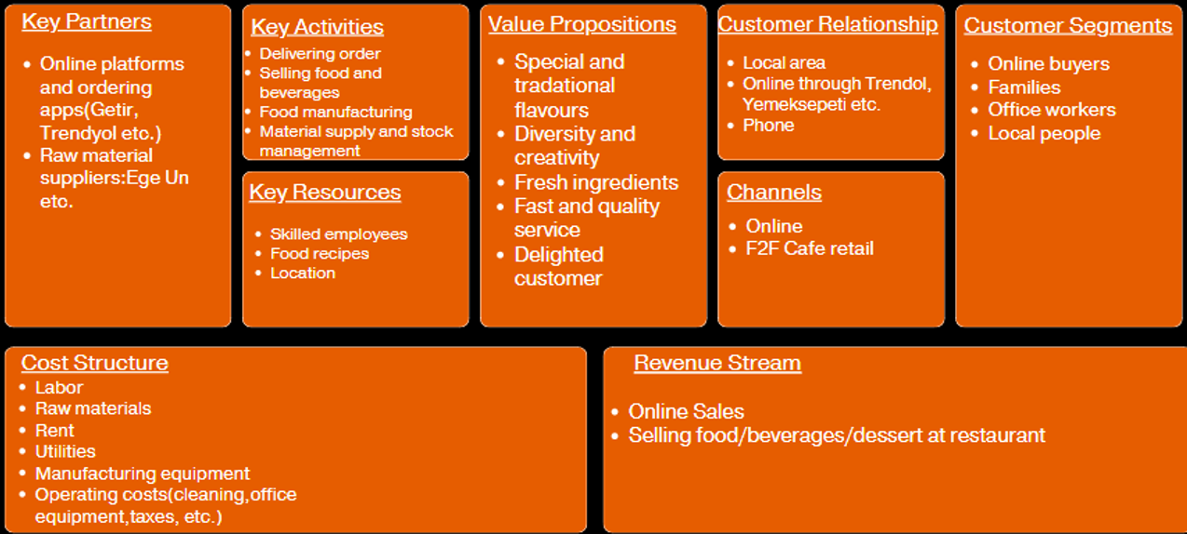

**Value Propositions:** With unique and traditional flavors crafted from the freshest ingredients, Ora delivers meals with fast and quality service. Our commitment to diversity and creativity ensures a delightful experience for every customer.

**Channels**: Ora offers unique and traditional flavors through online channels and face-to-face at café retail locations.

**Customer Relationship**: Ora build strong customer relationships through local area engagement, online platforms like Trendyol and Yemeksepeti, and phone communication.

**Customer Segments**: Ora’s customer segments include online buyers, families, office workers, and local people.

**Key activities**: Ora’s key activities encompass delivering orders and selling food and beverages, along with food manufacturing. Ora also focuses on managing material supply and stock effectively.

**Key resources**: Ora’s key resources include skilled employees, proprietary food recipes, and prime location.

**Key partners**: includes online platforms and ordering apps like Getir and Trendyol, as well as raw material suppliers such as Ege Un.

**Cost structure**: includes labor, raw materials, rent, utilities, manufacturing equipment, and operating costs such as cleaning, office equipment, and taxes.

**Revenue stream**: includes online sales and selling food, beverages, and desserts.

1.2 Swot Analysis

**STRENGHTS**

* Strong supply chain management
* Location
* Well trained and experienced chefs and staff
* Special and tradational flavors
* Same taste in every branch

**OPPORTUNITIES**

* Social media
* Product diversification

**WEAKNESSES**

* High operating cost
* Social media management
* Fluctuations in service quality during peak hours

**THREATS**

* Lack of qualified employees
* Inflation
* Intense competition
* Decrease in business

1.3 Revenue Stream

20% of the restaurant's total revenue comes from in-house sales, while 80% is generated from online sales. Of these sales, 20% are from items cooked on the grilled, such as kebab, and 80% are from items baked in the oven, such as lahmacun. The restaurant aims to maximize customer satisfaction with its wide range of products and high-quality service both in-house and on online platforms.

1.4 As-IS Process Flow

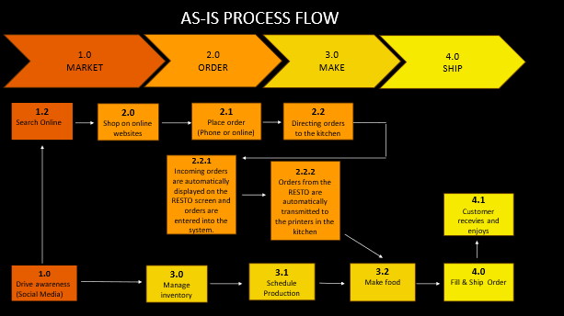

2. Current State Technology Inventory

Ora has integrated various technologies into its operations to cater to the evolving needs of its customers. Reviewing their existing technological infrastructure establishes a foundation for identifying potential improvements in the later sections of this report.

**Point of Sale(Pos) for restaurant:** Ora uses a Point of Sale (POS) system for restaurants. This system has several strengths, including the ability to collect detailed sales data and support multiple payment options. The annual cost for using this POS system is based on a 10% commission on sales per month.

**eCommerce Platforms:** Ora uses eCommerce platforms such as Getir, Vigo, YemekSepeti, and Trendyol to accept online orders. These platforms are integrated with Restopos, streamlining the ordering process and increasing efficiency. With Restopos integration, orders are directly sent to the restaurant's POS system, minimizing operational errors. The annual cost of using this system is determined by a 13% commission on sales per month. This method facilitates the management of both online and physical sales for the restaurant, helping it reach a broader customer base.

**Social Media** :Ora has social media accounts on Facebook and Instagram, each with over 1000 followers. While these platforms have the potential to reach a broad audience, the accounts are currently not sufficiently developed and are not actively used, posing a challenge for effective social media marketing and customer engagement.

**Financials:** Ora uses RestoPos, which is integrated with online sales platforms, streamlining order management and improving efficiency. The system has a monthly maintenance cost of 3500 TL, ensuring it remains operational and up-to-date.

**Order Management:** Ora uses a manual order management system for in-restaurant orders. This system offers flexibility and allows for personal communication with customers, enhancing the dining experience. However, it also presents challenges such as being time-consuming, prone to mistakes, and leading to a loss of productivity.

**Operational Management:** Ora uses RestoPos for operational management. This system is integrated with the kitchen, online order management, and table planning, ensuring smooth and efficient operations.

**Customer/ Contact Management:** Ora uses a telephone system for customer and contact management. This system provides strengths such as instant feedback, flexibility, and speed. However, it also faces challenges related to productivity and monitoring, time management, and potential loss of communication.

**Inventory Management:** Ora uses a manual inventory management system. This method offers simplicity and flexibility, allowing for straightforward handling of inventory. However, it faces significant challenges, including difficulty in traceability, risk of theft and loss, and a high risk of failure.

**Shift Planning:** Ora uses a manual system for shift planning. This method offers strengths such as flexibility and adaptability. However, it also presents challenges, including mistakes and confusion, which can impact overall efficiency.

3. Need Assessment

Ora, a leading restaurant in Turkey, aims to stay competitive and meet the evolving demands of its customers by conducting a comprehensive needs assessment. This assessment will identify key areas for improvement and provide a foundation for strategic enhancements in various aspects of the business.

**Business Strategy**

* Drive sales growth by attracting new customers through online channels.
* Improve the current social media strategy.
* Increase marketing efforts and brand awareness.
* Create a strategy for personal training and development.

**Functionality**

* Enhance the inventory management system and evaluate alternative tools.
* Develop a customer relationship management (CRM) process.
* Develop an order management system that integrates with RestoPos.
* Create social media management tools to support the current social media strategy.

**Data**

* Collect data on existing customers and their order life cycles.
* Capture potential customers through digital marketing efforts.
* Develop the capability to categorize prospects based on the sources they came from.

**Vendor/Project**

* Adhere to budgetary constraints when investing in technology.
* Ensure training is accessible for the tools provided by vendors.
* Implementing and maintaining technology tools should be straightforward and user-friendly.

4. Prioritization Matrix

To ensure the successful implementation of digital transformation at Ora, a prioritization matrix will be utilized. This matrix will help in identifying and ranking the key initiatives based on their impact and feasibility.

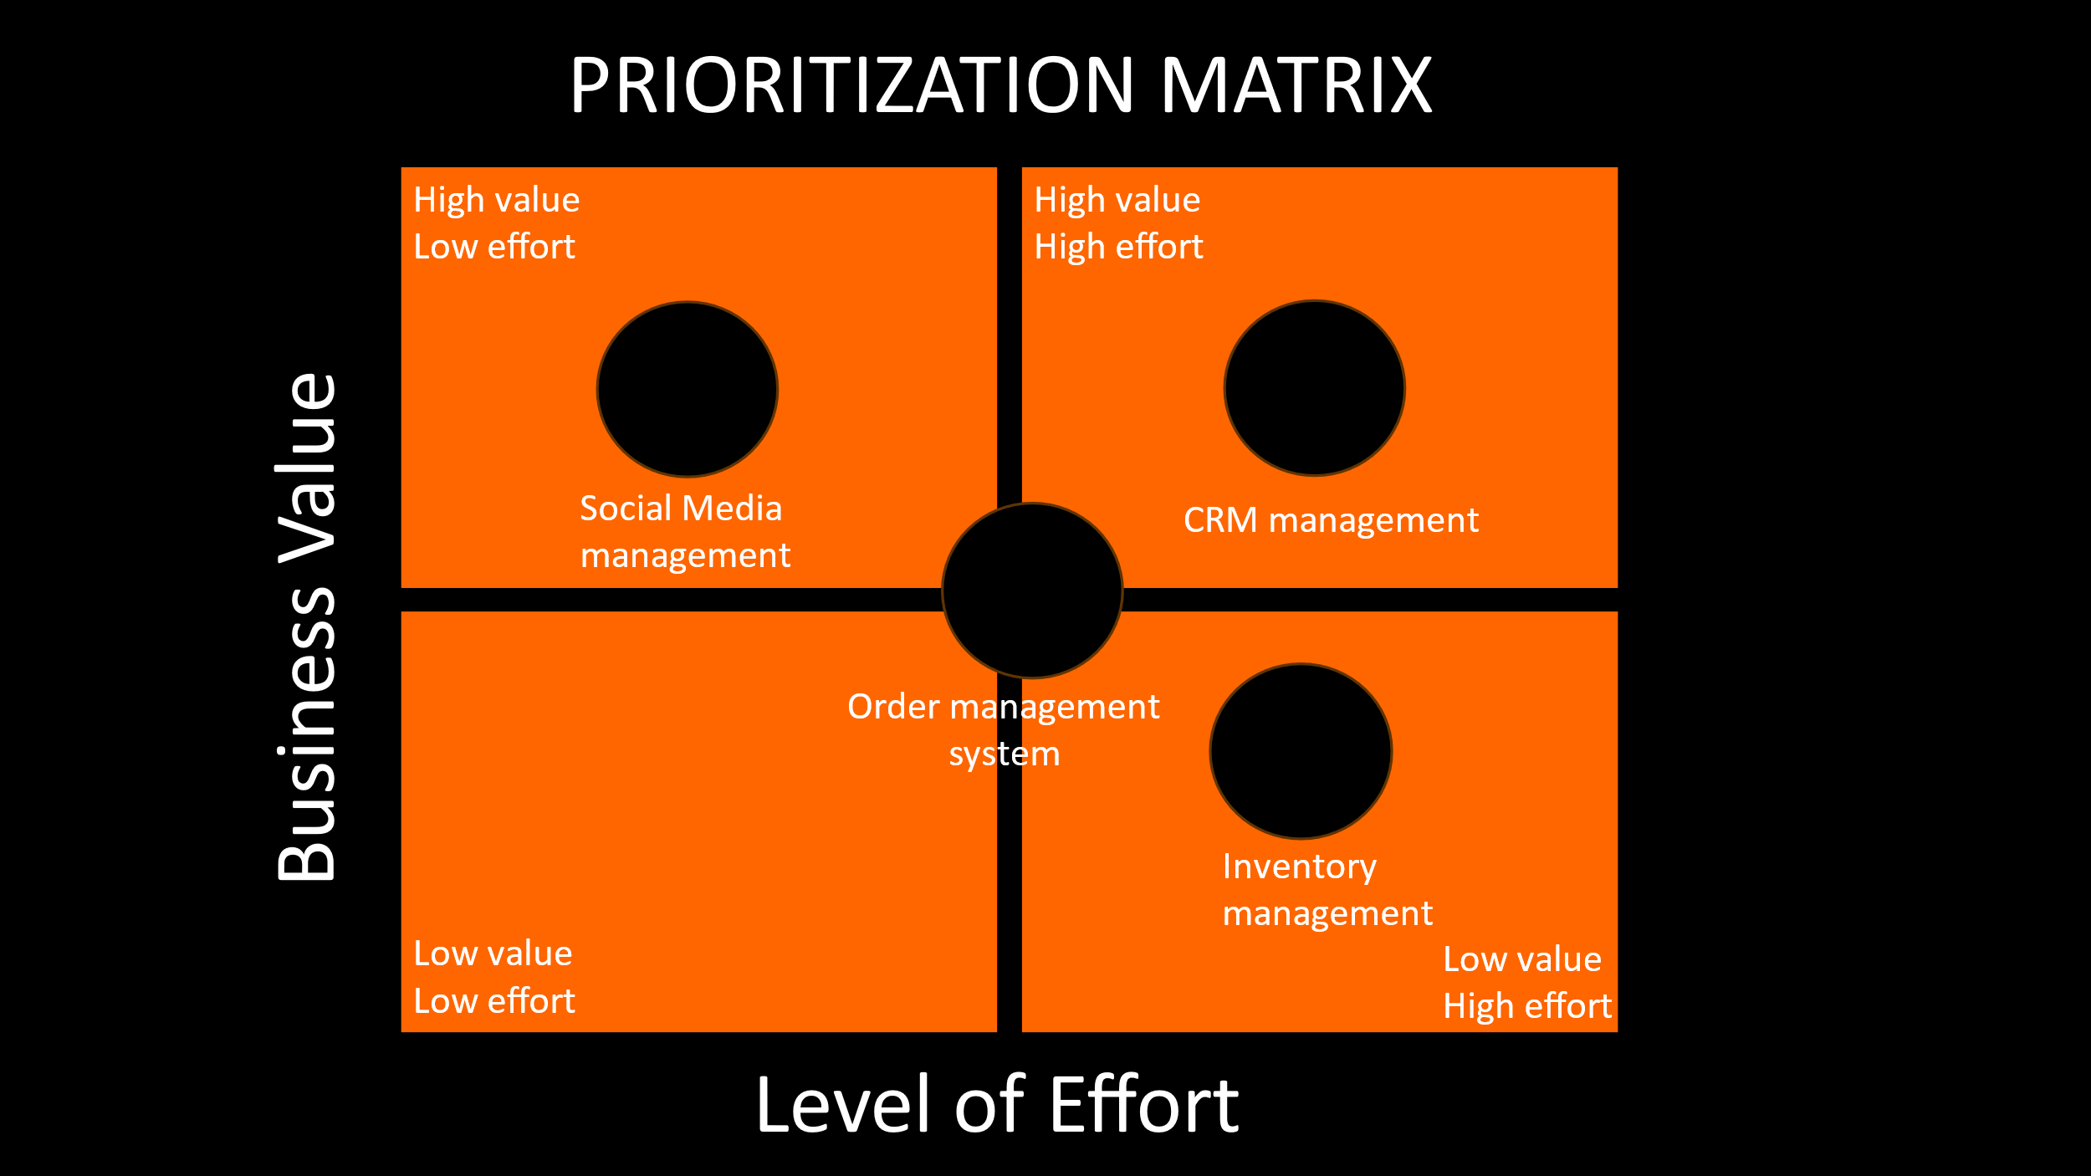

5. A Few Examples Worth Investigating

As Ora embarks on its digital transformation journey, several areas merit close examination to ensure the successful integration of new technologies and processes. These examples highlight potential opportunities for improvement and innovation.

**Funding:** Stripe, QuickBooks Online, FreshBooks

**Marketing Research:** SurveyMonkey, Qualtrics, Google Surveys

**Marketing Management:** HubSpot, Marketo, Mailchimp

**Marketing Social Measurement:** Sprout Social, Hootsuite, Buffer

**Sales:** Salesforce, Pipedrive, Zoho CRM, RestoPos, Ideasoft

**Research:** SurveyMonkey, Qualtrics, Google Forms

**Enterprise Management:** SAP Business One, Oracle NetSuite, Microsoft Dynamics 365

**E-commerce:** Shopify, WooCommerce, BigCommerce, Ikas

**Design:** Canva, Adobe Creative Cloud, Sketch, T-SOFT

**Fulfillment:** Yemeksepeti, Getir, Trendyol

**Service:** Zendesk, Freshdesk, Help Scout

6. People, Process Organizational Change

**People**: Regular training programs should be organized to enhance the existing staff's skills in using new technology tools and processes. These can come in various formats such as online courses, seminars, and workshops. Hiring should be done when necessary to acquire personnel who possess the required skills to manage and implement new technologies.

**Process**: A plan should be developed to integrate new technology tools into the operation. The customer relationship management process should encompass the collection, analysis, and utilization of customer data. There should be a designated team or individual responsible for monitoring and enhancing this process.

**Organizational Change**: Changes in technology and processes must align with the business culture. The change management plan should assist employees in accepting and embracing the changes All employees should be regularly provided with updated information about the change process. This can be accomplished through meetings, WhatsApp, email, internal communication tools, and communication via managers.

7. Technology Options

Ora has several technology options available to enhance its operations and better serve its customers. Here are some viable options: 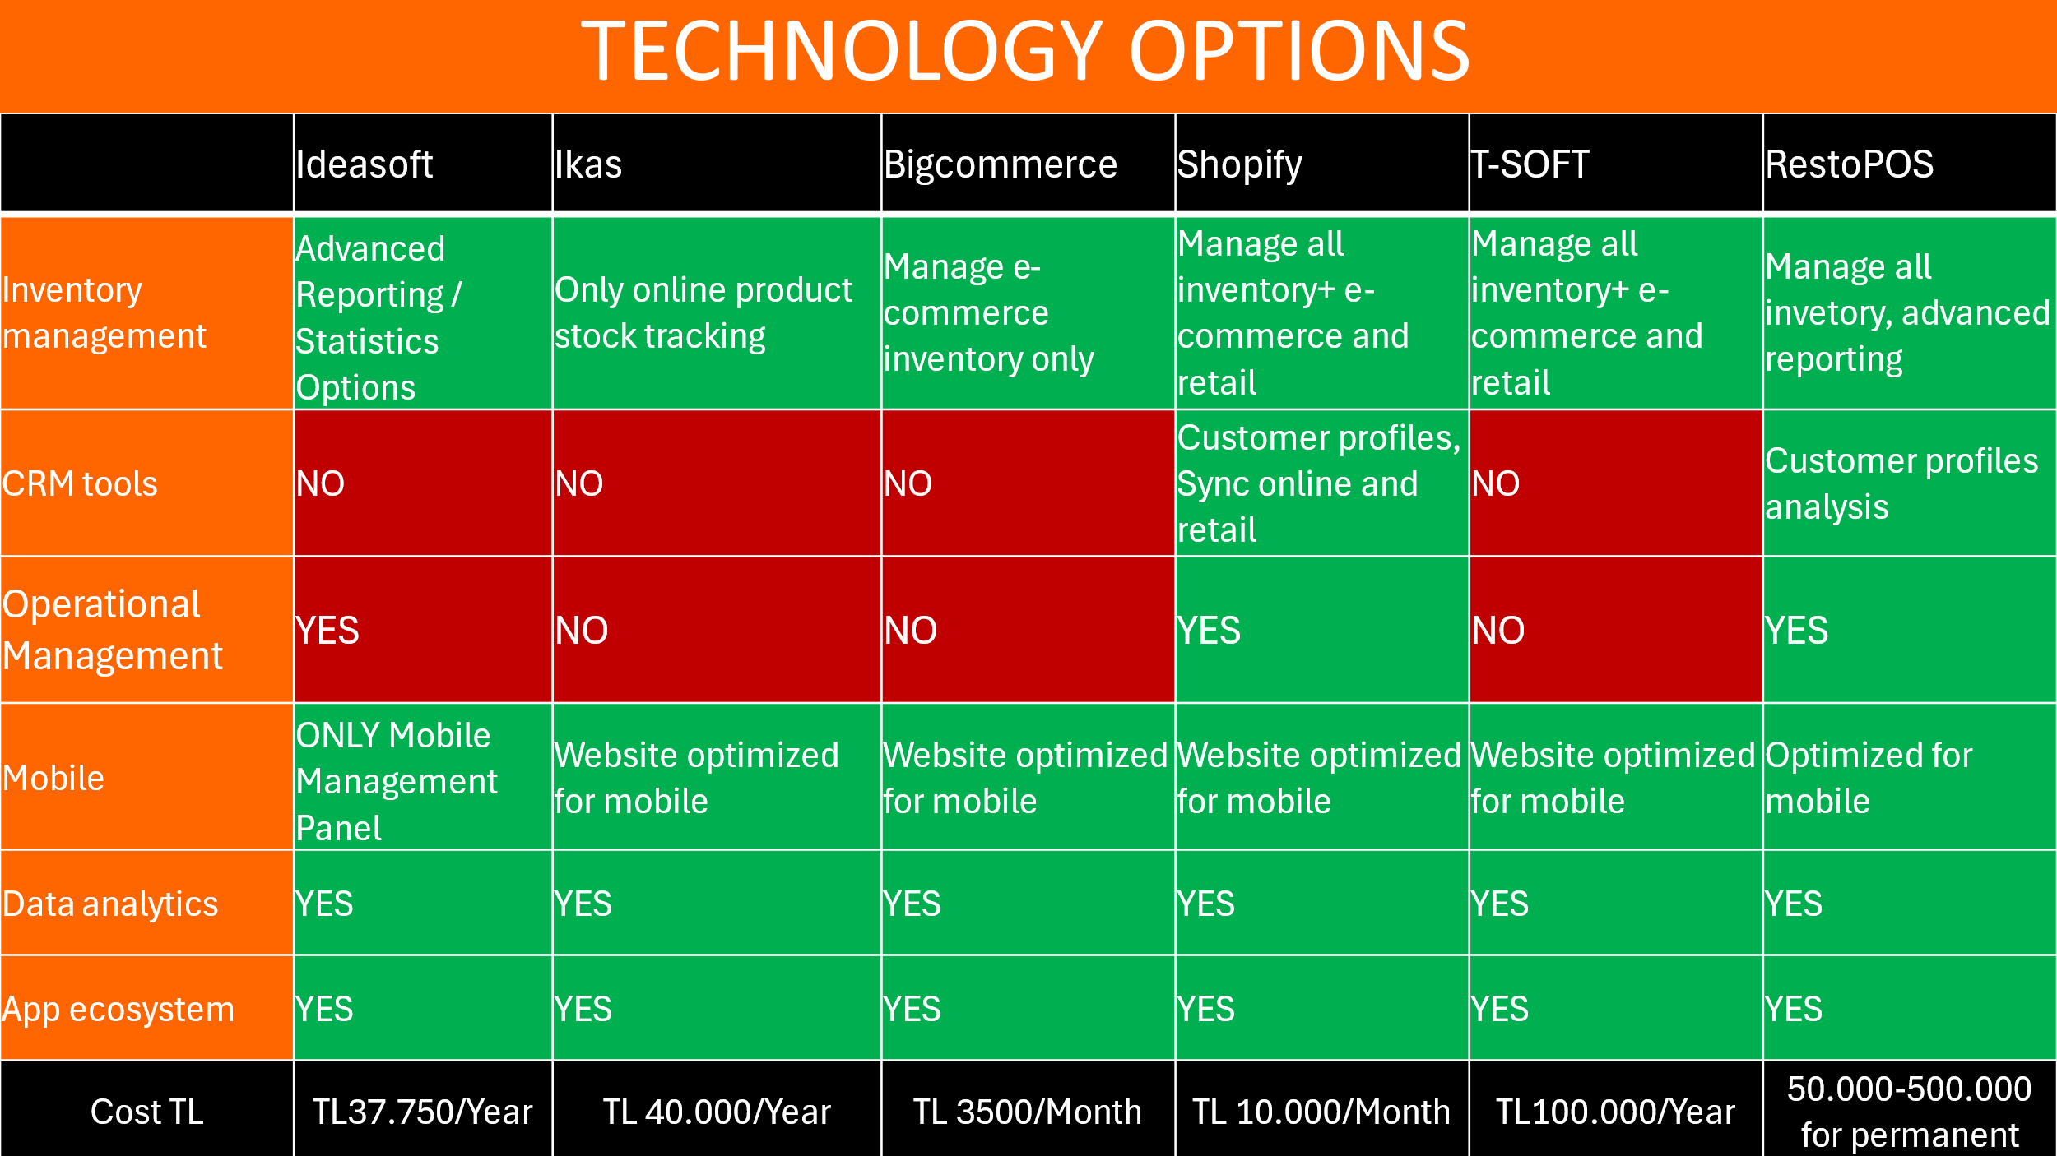

8. Technology Recommendation

RestoPos, the current platform used by Ora Lahmacun, is well-suited to address existing challenges as it consolidates all operational needs into a single platform.

**Long-Term Focus**

* **CRM Tools:** Enhance customer relationship management (CRM) tools to better understand customer preferences, improve engagement, and build loyalty.
* **Data Analytics:** Implement advanced data analytics to gain insights into customer behavior, sales trends, and operational efficiency. Use these insights to improve decision-making and enhance customer satisfaction.
* **Inventory Management:** Upgrade inventory management processes by implementing automated tools within RestoPos. This will optimize stock levels, reduce wastage, and improve overall inventory control.
* **Mobile and App Ecosystem:**
  + Develop a mobile app for Ora Lahmacun that integrates with RestoPos, allowing customers to place orders, make reservations, and provide feedback conveniently.
  + Implement features like loyalty programs, push notifications, and order tracking to enhance customer engagement and satisfaction.

**Short-Term Focus**

* Operational Management System: Streamline operational management systems to reduce congestion and increase efficiency within the restaurant.

These recommendations will help Ora Lahmacun leverage technology to optimize operations, improve customer experience, and maintain competitiveness in the market.

9.Social Media Management

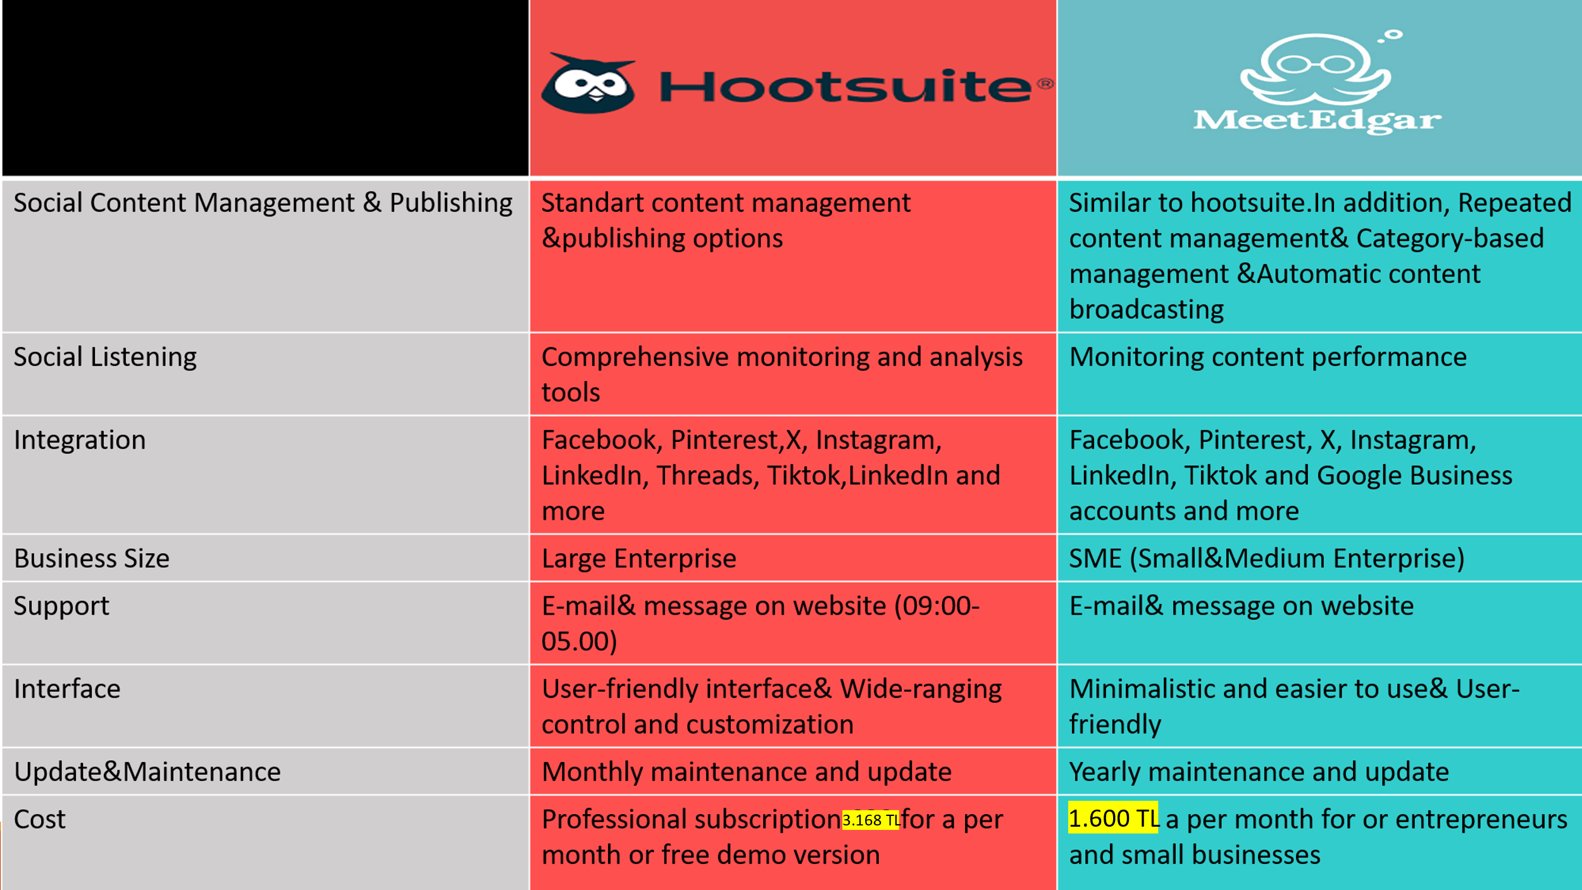

**Instagram:** Ora can use Instagram to showcase their products through sharing food photos on a visually-oriented platform. Additionally, they can announce daily specials or new menus. They can gather feedback to enhance customer satisfaction and engage with customers. Ora can use Instagram to promote their business, expand their customer base, and build a loyal customer following.

**Tiktok:** Ora can use TikTok because it's a platform where short and entertaining videos are shared. It provides a creative marketing space for businesses. By sharing engaging videos showcasing the process of preparing delicious or presenting different varieties, they can reach potential customers.

**Facebook**: Facebook provides tools for targeted advertising, allowing lahmacun sellers to reach specific demographic groups based on location, interests, and more. They can also attract customers by offering special deals, discounts, or events. In general, Facebook provides a comprehensive platform for lahmacun sellers to establish their online presence, reach potential customers, and foster customer relationships.

10. Implementation Roadmap

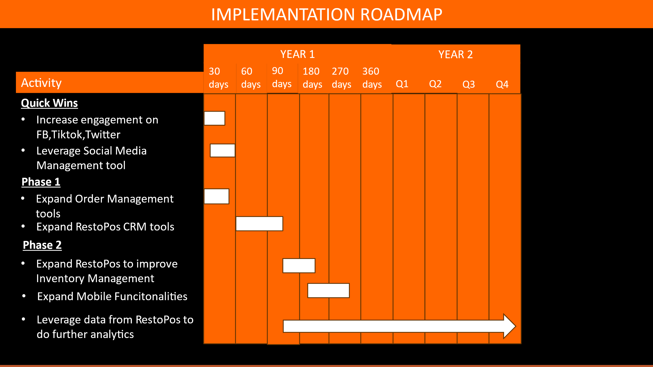

11. Technology Budget

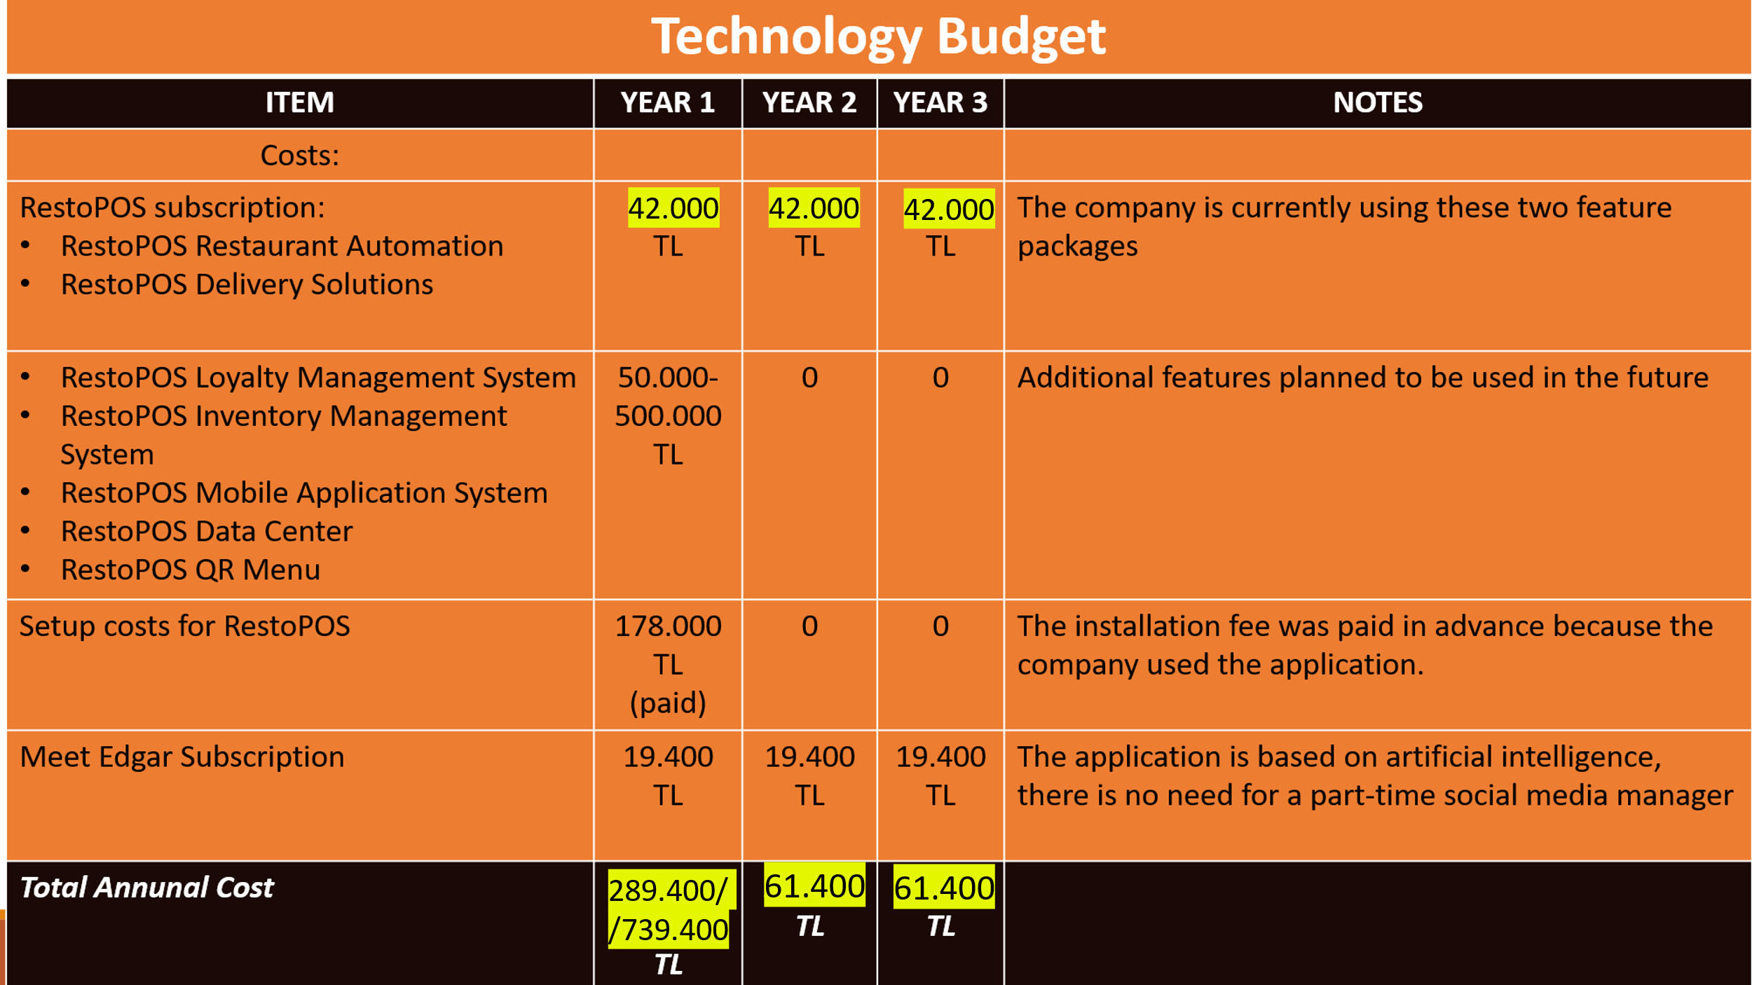

Ora’s technology total annual cost for the first year is between 289,400 TL and 739,400 TL, with an initial setup fee of 178,000 TL already paid. While the initial cost may seem high for the first year, it provides comprehensive solutions to current issues and can be considered a long-term investment. There will be no subscription fees for subsequent years, apart from monthly maintenance costs.

12. Impact to Business

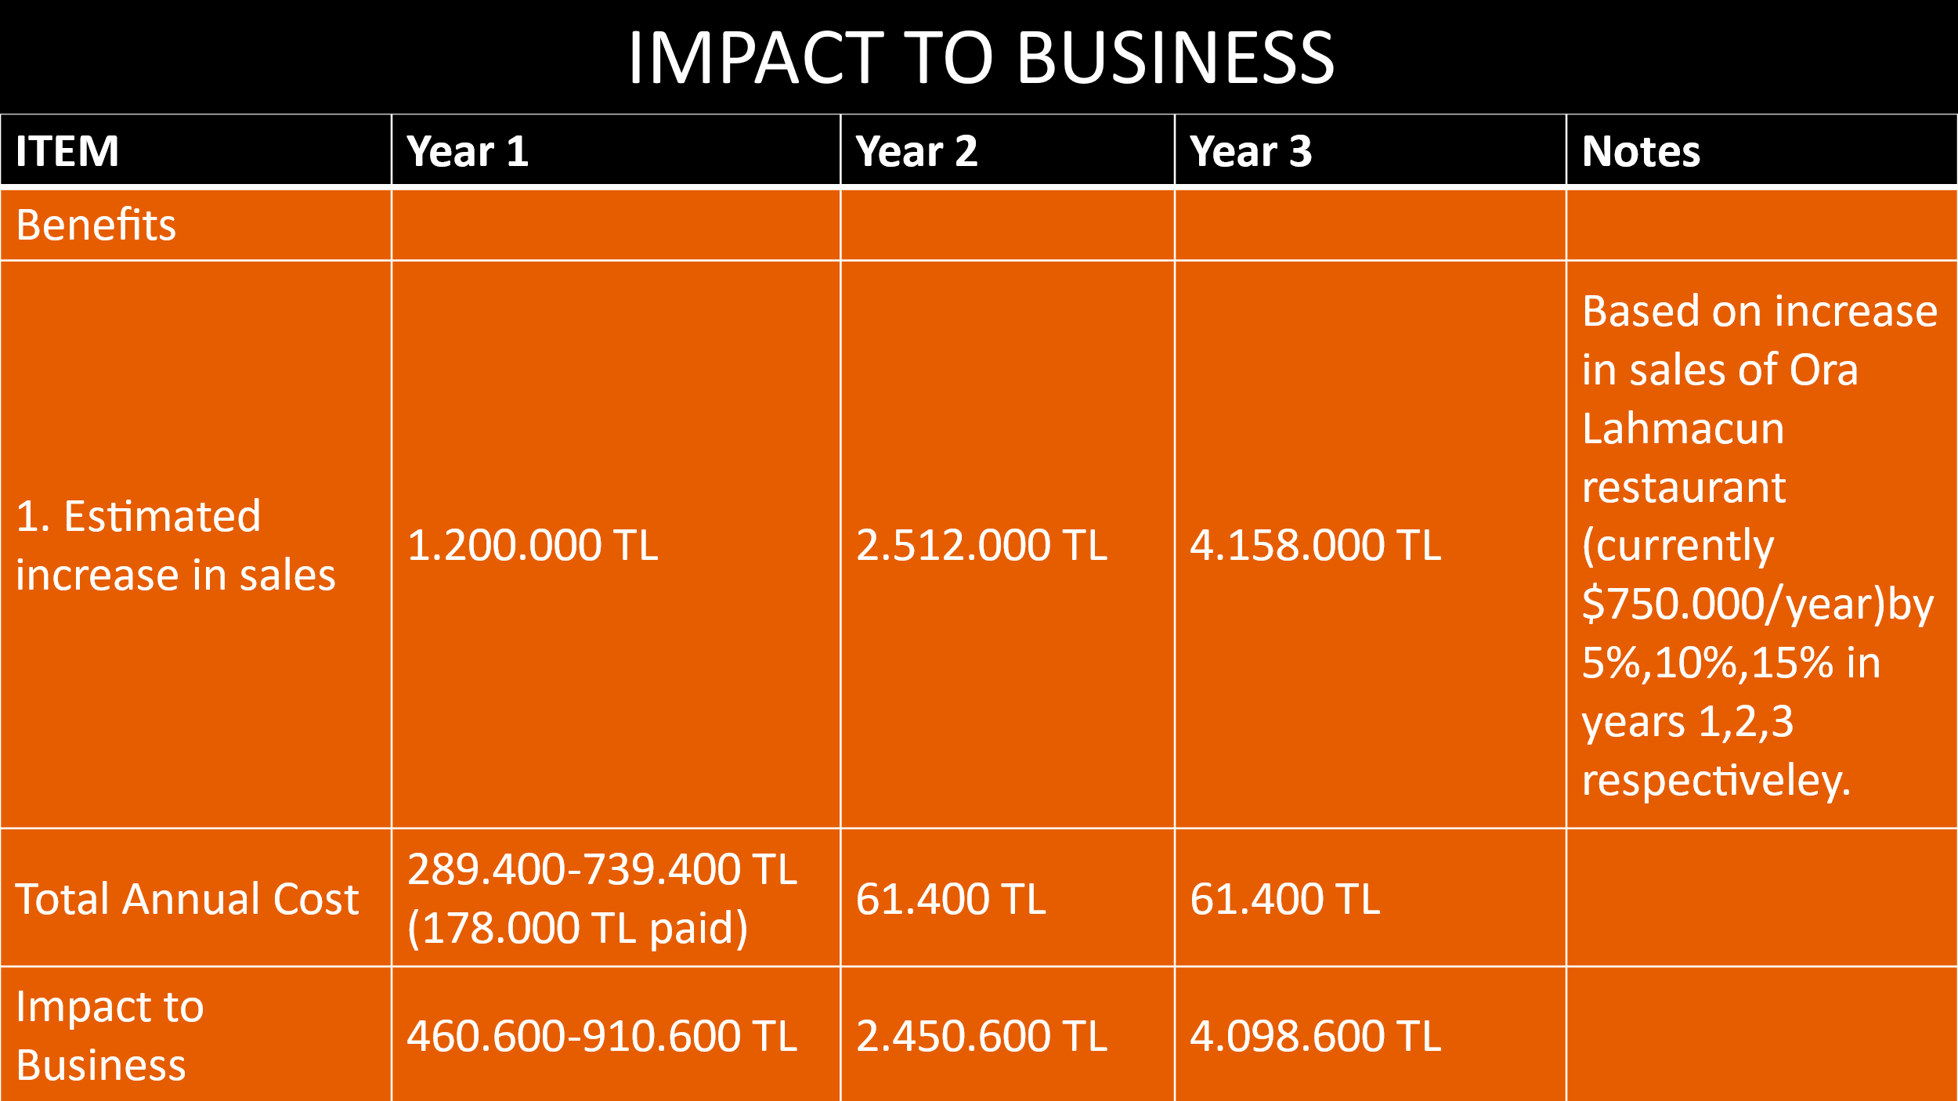

13. Business Metrics

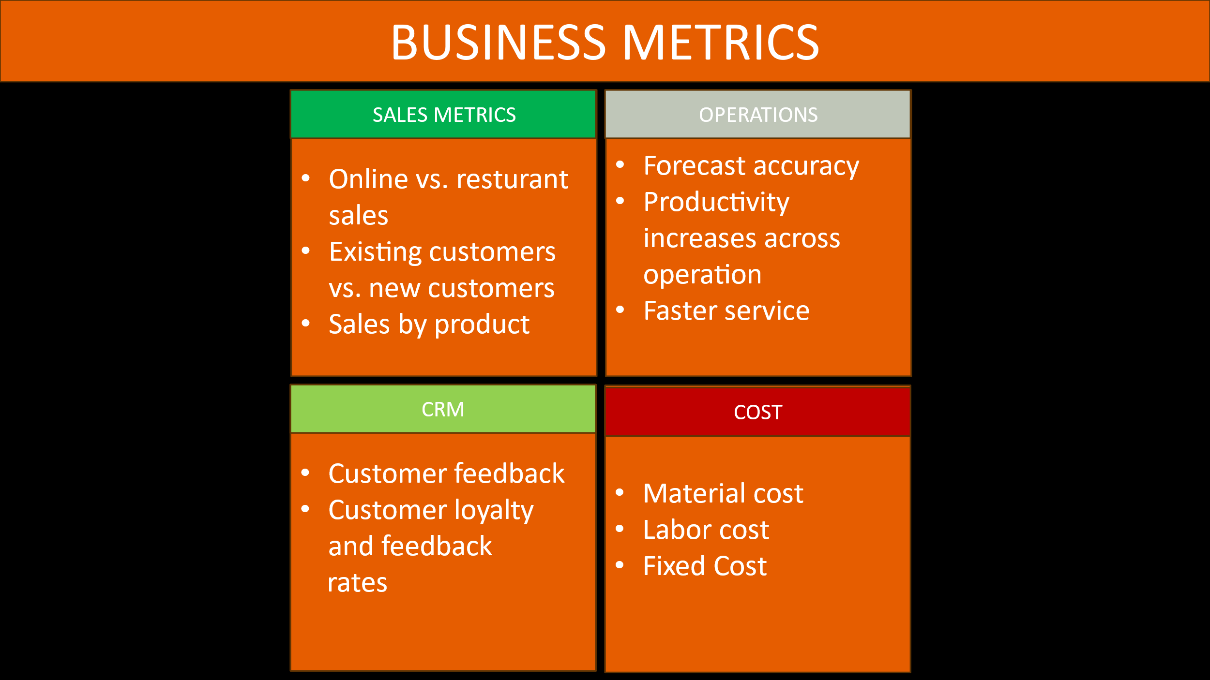

14. References

1-)<https://fintechistanbul.org/2023/03/20/tubisad-turkiyenin-dijital-donusum-endeksi-2022-raporu-yayimlandi/#:~:text=Bili%C5%9Fim%20Sanayicileri%20Derne%C4%9Fi%20(T%C3%9CB%C4%B0SAD)%20taraf%C4%B1ndan,3%2C12%20olarak%20tespit%20edildi>.

2-)<https://www.youtube.com/watch?v=hQc8cCuyLzA>

3-)<https://ora.web.tr/>